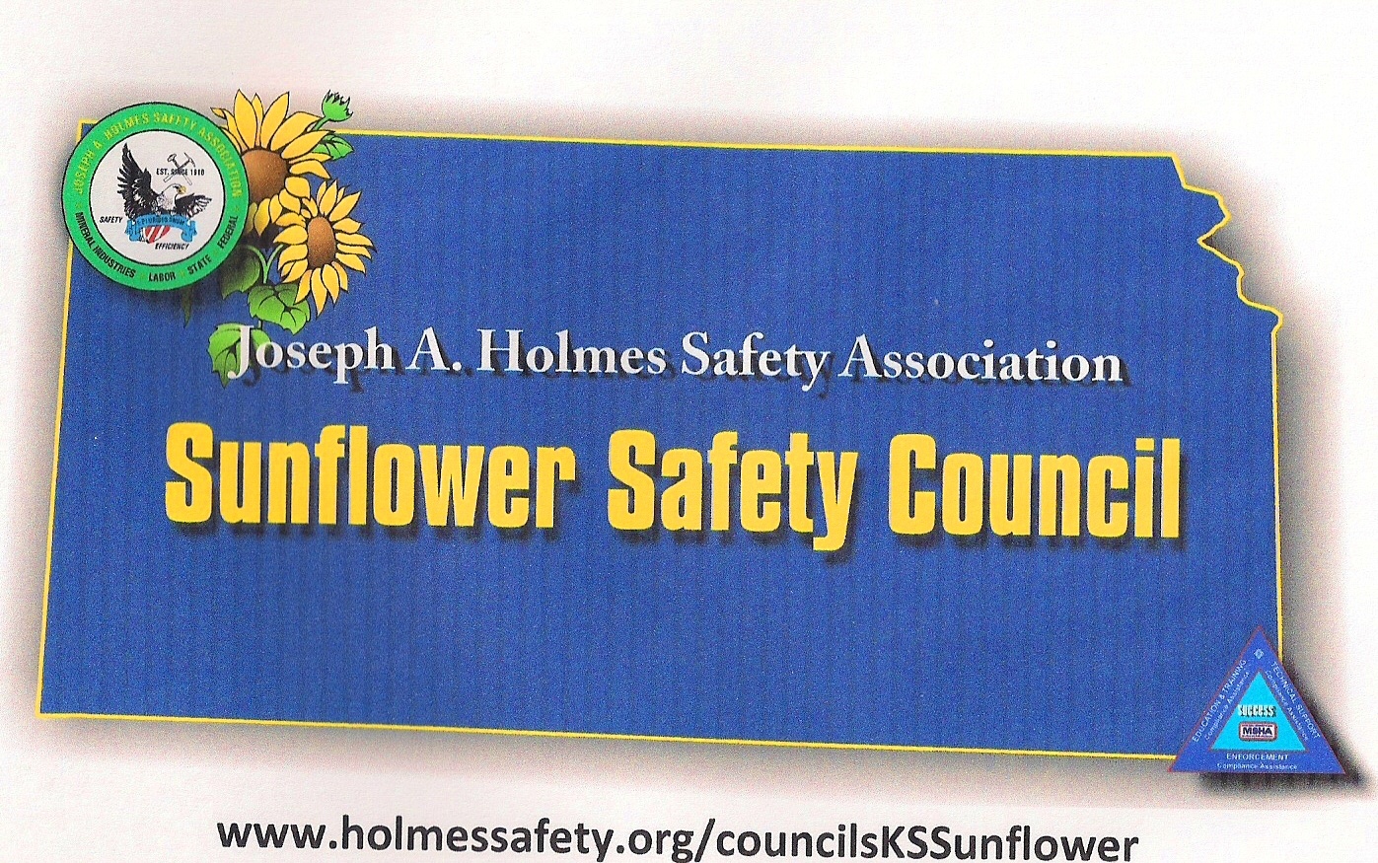
SUNFLOWER SAFETY COUNCIL
MEETING MINUTES
May 12, 2015
Hosted by MSHA in Topeka, KS

Meeting was called to order by Jim Barta, President, at 1:01 p.m. 22 members present. Individual introductions were made to the group.

SECRETARYS REPORT:
March meeting minutes were approved.

TREASURERS REPORT:
There is a total of $2757.74 in the account. Treasurers’ report was accepted.

OLD BUSINESS:
There was no old business to discuss.

SAFTEY TOPIC: Electrical Standards were discussed by Mike Perry, MSHA Inspector. The items discussed were:
- 56/57.12028 – continuity and resistance testing
- Resistance in ground systems.
- Ohms results needed
- Fall of potential meters
- Flute meters
- GFCI’s and testing of them
- Arc Flash and where MSHA stands on the enforcement of it.
- Double insulated tools
- Pad transformers checks
- Welding clamp issues
- Portable light fixtures

The MSHA electrical trailer is coming to Kansas in July. Please let Wally Pitney know if you are interested in seeing it.

NEW BUSINESS:

Fall protection should be taken out of service based on manufacturer’s recommendation. A “Buddy” check is recommended.

We discussed a Jackson and Kelly news release about MSHA’s impending changes.

The Summary of 2015 fatal accidents was discussed.

HCC hired a new employee, Jason Eaves.

We discussed some MSHA citations.

The next meeting will be in Manhattan at Midwest Concrete on July 21, 2015 at 12 noon. The MSHA electrical trailer will be there and we need a little extra time to get through it

Meeting was adjourned at 2:45 pm

